**Streaming Analytics**



Streaming analytics is a branch of data analytics that deals with the processing and analysis of continuous flowing data. The concept of real time data analysis is relatively new but a rapidly growing field in the industry. In the past, there wasn’t a demand to analyze data in real time and alternate analytics methods like batch processing where data was stored in storage centres and then sent out to be processed in batches was enough to keep up with the market’s demand. However, with the rise of the internet and it being integrated with nearly every facet of our lives the demand for the vast amount data to be processed in real time or with very low latency has sky rocketed. Streaming analytics which also known as Event Stream Processing allows the continuous processing and analysis of data as it is generated allowing companies to gain insight into their operations and make the necessary changes in order to optimise their output. It draws upon data from various sources like sensors, social media feeds, transactional systems, log files, IoT devices and many more. The organization can then apply their custom queries also known as event streams to the data being streamed when a particular event is triggered, like a financial transaction, a security score etc. It allows the organization take calculated decisions by detecting upcoming trends, opportunities, and risks. It is especially useful in use cases like fraud detection, real time user behaviour analysis and supply chain optimization. In addition to this, streaming analytics offer various advantages over traditional analytics methods, which include:

* **Visualisation of data:** Key performance indicators (KPIs) can be managed on a daily basis by organisations by keeping an eye on the most crucial company data. Companies may keep track of streaming data in real time to understand what is happening at all times.
* **Business knowledge:** If an unusual business event occurs, it will first appear in the appropriate dashboard. It can be applied to cybersecurity to automate threat identification and reaction. Abnormal behaviour in this area needs to be noted and looked into straight away.
* **Rise in competition:** Streaming data can be used by companies seeking a competitive edge to identify patterns and establish standards more quickly. In this approach, they can advance faster than their rivals who are still employing batch analysis.
* **Eliminating losses:** We can avert or at least lessen the effects of events like security breaches, manufacturing problems, customer attrition, stock exchange meltdowns, and social media crises with the use of streaming analytics.
* **Examining common business processes:** Organisations have the chance to consume and instantly get insight from the real-time data that is flooding in thanks to streaming analytics.

**Evolution of Streaming Analytics:**

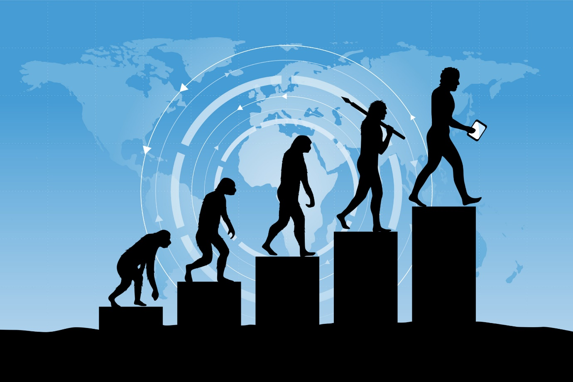

Streaming analytics has gone through many evolutions over time in order to meet the various demands of the industries it has been deployed in. Some of the factors that have driven these evolutions include growing volume and velocity of data, the variety of data being generated and complex queries to be applied. Below we have some of the crucial stages in its evolution:

* **Real-Time Analytics:** As high-frequency trading in the financial sector increased, a demand for real-time data analysis arose. Making split-second trading decisions required the processing and analysis of streaming data from stock exchanges and other financial sources. Real-time analytics were established at this early stage, laying the groundwork for further developments.
* **Complicated Event Processing (CEP):** is a method for real-time detection of complicated patterns, correlations, and events in streaming data. By applying rules, filters, and temporal analysis to data streams, CEP made it possible to find significant occurrences. Applications for fraud detection, network monitoring, and supply chain optimisation were created as a result of the ability for organisations to monitor and respond to events as they happened.
* **Distributed Stream Processing:** Traditional analytics systems were unable to keep up with the speed and volume of data that was increasing. To handle massive, real-time data processing, distributed stream processing frameworks like Apache Kafka, Apache Flink, and Apache Spark Streaming were developed. Organisations were able to process and analyse streaming data at scale thanks to these frameworks' fault tolerance, parallel processing, scalability, and event time processing capabilities.
* **Integration with Big Data Ecosystems:** Real-time streaming data is combined with historical and batch data for thorough analysis in streaming analytics, which has evolved to integrate with big data ecosystems. Organisations are now able to store, process, and analyse large volumes of data in real-time and run sophisticated queries across batch and streaming data sources thanks to technologies like Apache Hadoop, Apache Hive, and Apache HBase.
* **Integration with Machine Learning and AI:** By integrating with machine learning and artificial intelligence methods, streaming analytics increased its potential. Real-time predictive analytics, anomaly detection, and pattern identification on streaming data were made possible by this integration. In order to train and update machine learning models in real-time, businesses started using streaming analytics. This led to applications in fraud protection, predictive maintenance, personalised recommendations, and more.
* **Cloud-based streaming analytics:** Scalable, on-demand infrastructure and analytics platforms made possible by cloud computing and managed services revolutionised streaming analytics. Fully managed streaming analytics services like Amazon Kinesis, Google Cloud Dataflow, and Azure Stream Analytics have been introduced by cloud providers like Amazon Web Services, Google Cloud Platform, and Microsoft Azure. These services abstracted the infrastructure management's complexities, allowing businesses to concentrate on data analysis and insights.
* **Integration of edge computing and the Internet of Things (IoT**) has created new opportunities and problems for streaming analytics. To reduce latency and enable real-time decision-making, businesses began analysing and acting on data at the network's edge, close to the data source. In order to manage edge devices, process data locally, and deliver only pertinent insights and events to centralised systems, streaming analytics was expanded.

**Working Of Streaming Analytics:**

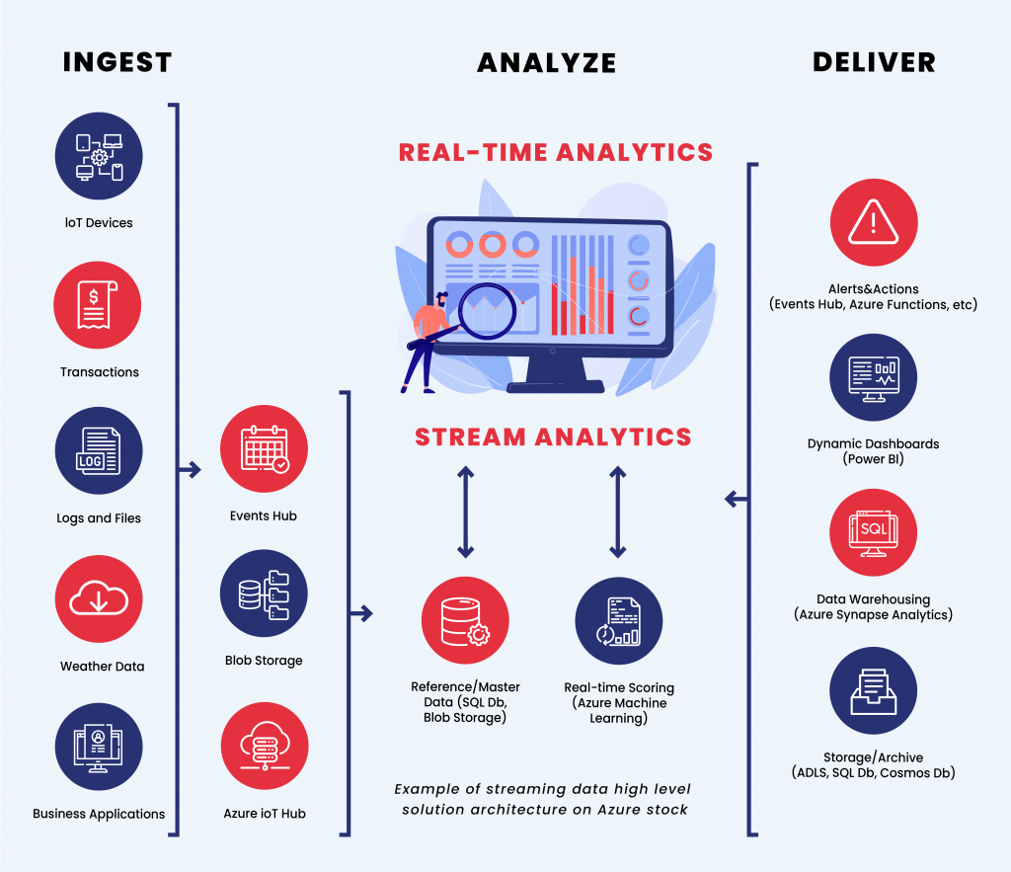

There are multiple steps in the analysis of streaming data but they can broadly divided into the following:

* **Data Ingestion:** from diverse sources is the first step in the streaming analytics process. These sources could be IoT devices, transactional systems, log files, social media feeds, sensors, social media feeds, or any other systems that provide streaming data. Normally, the data is received as discrete events or in short, time-ordered chunks.
* **Data processing**: After the data is ingested, it goes through real-time processing. Complex event processing (CEP) techniques are used by streaming analytics platforms to analyse and interpret the data streams. As part of the processing stage, the data may be filtered, converted, aggregated, enriched, or integrated with data from other sources.
* **Event detection:** As the data streams are processed, the streaming analytics platform finds pertinent events or circumstances. Based on business rules or logic, statistical models, or machine learning algorithms, these events may be predefined. The platform searches for trends, correlations, outliers, or thresholds that point to the occurrence of significant events.
* **Action:** The streaming analytics platform initiates actions or notifications in response to the detection of an event of interest. These procedures may include creating alerts, notifying pertinent parties, updating dashboards or visualisations, utilising other services, or starting automated workflows. The course of action is determined by the particular use case and the desired results.
* **Continuous Streaming:** is a procedure that runs in real-time or very close to real-time. The steps of event detection and action triggering are repeatedly iterated while the data streams are being continually analysed. Organisations are guaranteed to have the most recent insights and be able to react quickly to events or conditions that are changing through the use of this iterative approach.
* **Output and Visualisation:** Visualisations, dashboards, or reports are frequently used to convey the insights obtained through the streaming analytics process. These results give stakeholders a clear picture of the data's current state, key metrics, trends, anomalies, and useful insights.

**Event Detection Methods:**

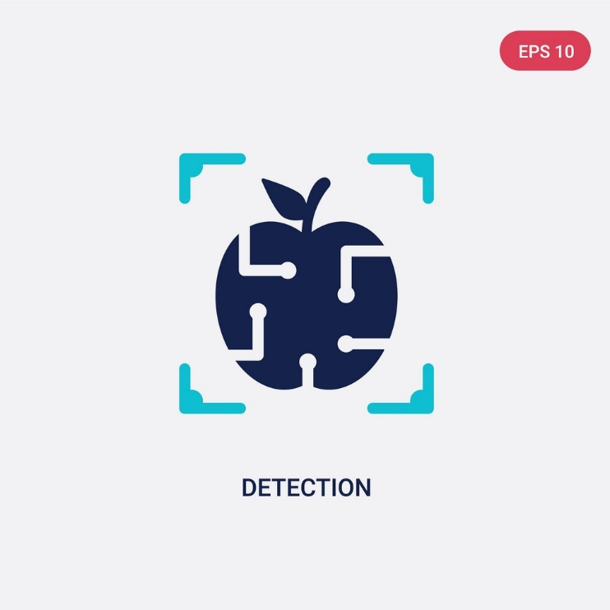

The event detection method used for streaming analytics will differ from organisation to organisation. There multiple methods to choose from each with its own specific use case and advantages. These methods are sometimes even combined to optimise the analytical capabilities of the streaming processing frameworks. Some of the commonly used methods include:

* **Data stream mining:** is the process of using machine learning and conventional data mining algorithms to stream data. It focuses on sifting through the constant stream of data to find patterns, trends, and anomalies. It is possible to modify methods like clustering, classification, regression, and anomaly detection to work in a streaming situation.
* **Online machine learning**: As fresh data come in, online machine learning approaches allow for continuous learning and model adaption. Streaming data can be handled using algorithms like online clustering, online classification, and online regression that update models progressively rather than requiring retraining on the complete dataset.
* **Time Series Analysis**: When analysing streaming data that displays temporal dependencies, time series analysis is especially helpful. Techniques like forecasting, trend analysis, seasonal decomposition, and anomaly detection in time series data can provide valuable insights in real-time.
* **Rule-based Systems:** With the use of rule-based systems, streaming data may be processed and analysed. These rules can be applied to data streams to find particular circumstances, occurrences, or patterns. The infrastructure to develop, manage, and execute rules in real-time is provided by rule engines or rule-based systems.
* **Complex Event Processing:** It works by identifying patterns, correaltions and complex event within a particular data stream. The complex event can change from one stream to another and it is assigned based the organization’s requirements. It uses multiple techniques like event-based processing, event pattern matching, and continuous querying.

**Use Case:**

Streaming analytics have a lot of use cases that cross over into many fields in the industry but here listed below are some of the major ones:

* Real-time Traffic Analysis: Streaming analytics can analyze real-time traffic data from various sources, including GPS, sensors, and social media, to monitor traffic patterns, detect congestion, and optimize routing in real-time. It helps in improving traffic flow and reducing travel times.
* Real-time Fraud Detection: Streaming analytics can analyze incoming data streams in real-time to detect patterns and anomalies indicative of fraudulent activities, enabling proactive identification and prevention of fraudulent transactions.
* Predictive Maintenance: By continuously analyzing sensor data from equipment in real-time, streaming analytics can identify patterns and anomalies that indicate potential maintenance needs, enabling organizations to schedule maintenance activities before critical failures occur.
* OTT Optimization: Streaming analytics allows you to analyze user behavior to the various content your platform to better optimize the content that you can provide in order to boost ad revenues and get higher levels of user engagement

However, the use case that will be the focus of this blog will be financial analysis.

**Financial Analysis:**

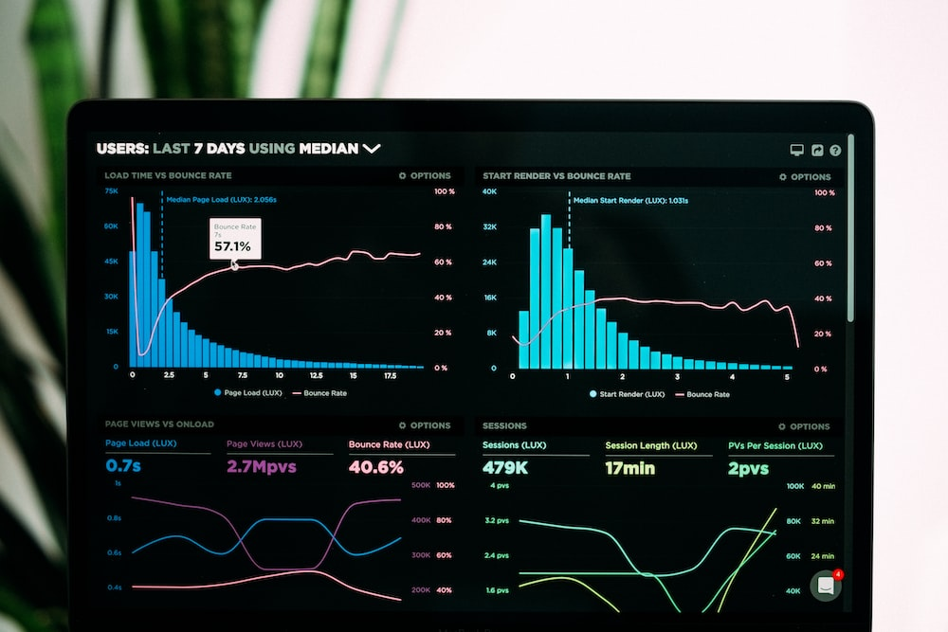

Financial analysis refers to the process of evaluating and interpreting financial data to gain insights into the financial performance, stability, and prospects of an individual or organization. It involves examining financial statements, ratios, trends, and other financial metrics to assess the financial health, profitability, liquidity, solvency, and efficiency of a business. Financial analysis helps stakeholders, including investors, creditors, managers, and analysts, allocate resources effectively, manage risks, and evaluate the overall financial viability of an entity. Financial analysis is very crucial and can often make or break organizations. It allows organizations to make informed business decides like investment opportunities, assess financial performance, and determine the feasibility of projects or initiatives. This is especially necessary in today’s volatile economic condition where you should be able to identify and assess risks associated with investments, operations, and other financial decisions. It allows companies and analysts to draw up risk management strategies and protect their own financial well-being. However, a key thing to note about the financial landscape is its constantly shifting nature that requires constant monitoring and storing of data in order to analyze it but this can only take you so far in terms of predicting future trends of the market and optimizing your decision-making process. This is where streaming analytics comes in which provides with the ability to analyse data as they are generated making predictions faster and as up to date as possible leading to more safer decisions and strategies. The following are some of the applications of streaming analytics in financial analysis:

* Real-Time Market Data Analysis: Streaming analytics processes and analyzes real-time market data, including stock prices, currency rates, and market indexes. It enables traders and financial analysts to monitor market movements, detect patterns, and make informed trading decisions.
* Algorithmic Trading: Streaming analytics is crucial for algorithmic trading, where real-time data analysis and automated trading strategies are employed. It makes it possible to recognise trading signals, carry out trades, and manage risk in milliseconds or microseconds.
* Fraud Detection and Risk Management: Streaming analytics helps discover fraudulent transactions, unauthorized access, and suspicious behaviours in real-time. It applies advanced analytics and machine learning algorithms to evaluate transactional trends, detect abnormalities, and minimise risks.
* Portfolio Optimization: Streaming analytics allows real-time portfolio monitoring and optimization by analyzing market data, portfolio performance, and risk metrics. It promotes the identification of opportunities, rebalancing techniques, and risk-adjusted decision-making.
* News and Sentiment Analysis: Streaming analytics assesses market sentiment and sentiment-driven price movements in real-time by analysing news feeds, social media sentiment, and other textual data sources. It helps financial analysts gauge market sentiment, anticipate market reactions, and adjust investment strategies accordingly.
* Monitoring for Compliance and Regulatory Requirements: Using streaming analytics, financial institutions can monitor transactions and events for regulatory compliance. It provides real-time identification of suspicious activity, fraud, money laundering, and conformity to regulatory norms.
* Market Surveillance: Streaming analytics is applied for market surveillance to uncover market manipulation, insider trading, and other unlawful behaviours. It supports the ongoing real-time market integrity monitoring of trade activity by regulatory agencies and exchanges.
* High-Frequency Trading (HFT) Analysis: Streaming analytics plays a significant role in high-frequency trading, where rapid processing of market data is necessary. It facilitates the execution of complex trading algorithms, discovery of arbitrage opportunities, and latency-sensitive decision-making.

In my use case, I am using the NIFTY-50 Stock Market Data (2000 - 2021) dataset from Kaggle. The dataset consists of the price history and trading volumes of the fifty stocks in the index NIFTY 50 from NSE (National Stock Exchange) India. All datasets are at a day-level with pricing and trading values split across .cvs files for each stock along with a metadata file with some macro-information about the stocks itself. The data spans from 1st January, 2000 to 30th April, 2021.

**Dataset Link:**

<https://www.kaggle.com/datasets/rohanrao/nifty50-stock-market-data>

**Dataset Screenshot:**

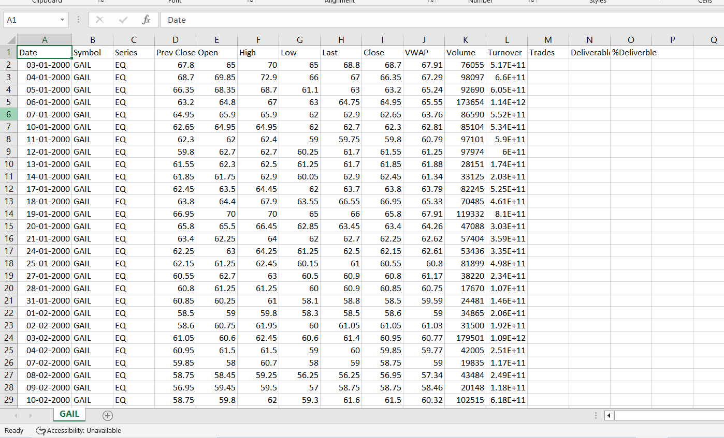

**Apache Kafka:**

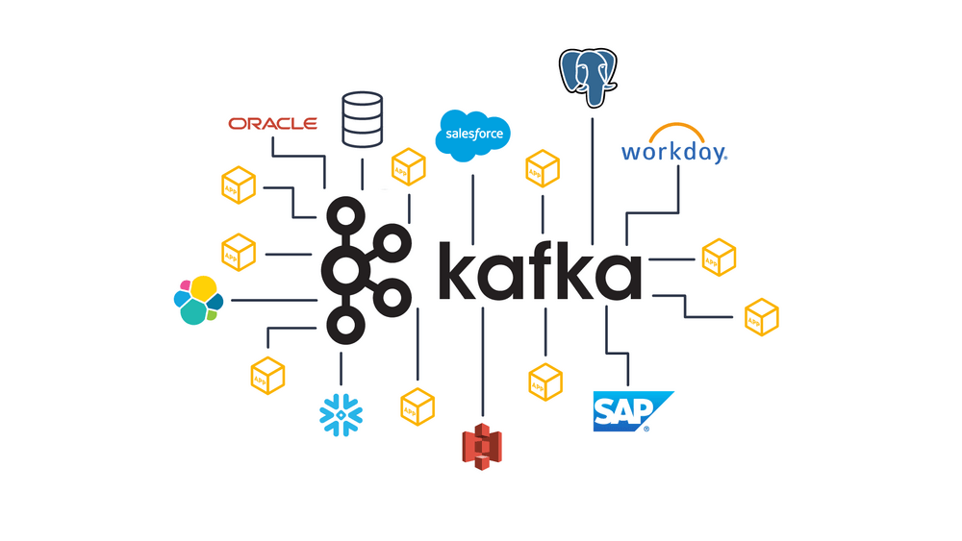

The data is streamed with the help of Apache Kafka which is an open-source streaming analytics tool by Apache that that can handle large-scale, high-throughput data streams and provides features for real-time data processing. It is a producer-consumer architecture where we have a producer that will inject the data into the kafka broker server and a consumer that retrieves the data from the server and performs a function or analysis on the retrieved data. Apache Kafka consists of two servers the Kafka broker server and the Zookeeper server.

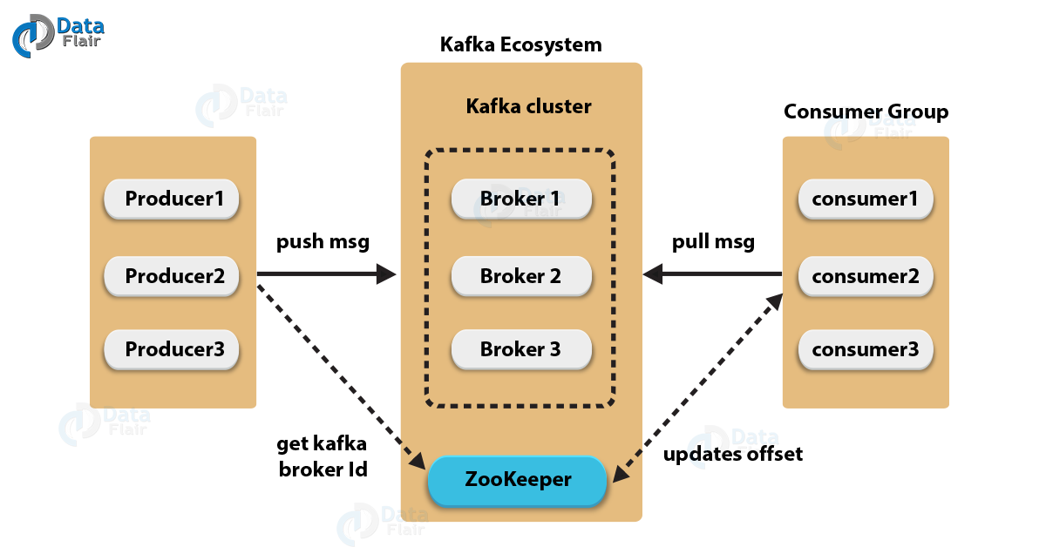

**Kafka Broker Server:**

The Kafka broker server is what connects the producer with the consumer and is responsible for the passing off the data itself as well as the metadata. The kafka broker consists of kafka topics which is a grouping of messages that is used to organize messages for production and consumption. A topic will consist of multiple partitions that can be identified using an unique offset in the partition log.

**Zookeeper Server:**

The Zookeeper on the other hand is in charge of maintain the kafka broker clusters. It maintains a record of when a broker enters or leaves a cluster as well as is responsible for electing the leader broker for a cluster. Its functions include distributed configuration services, synchronization services, and a naming registry.

**Moving Average:**

Moving average is a statistical calculation used to analyze data points over a specific time period by smoothing out fluctuations and revealing underlying trends. It is commonly applied in time series analysis and financial analysis. The moving average is calculated by taking the average value of a set of data points within a defined window or period. The window can be a fixed number of periods or can be based on a specific time interval. With each new data point, the oldest data point is dropped from the calculation, and the newest data point is added. It help reduce noise in data, highlight trends, and provide a clearer picture of the underlying pattern. They are widely used to identify support and resistance levels, determine trend direction, generate trading signals, and assess the overall momentum of a data series.

The use case that I am working with consists of a producer python code that pushes a “.csv” file into the kafka server and a consumer python code that reads the “.csv file” from it and performs moving average on the data as it is being streaming from the server. The moving average is done on the closing prices for two time periods, over 7 days and 30 days. The average value calculated is then plotted on a dynamically updating graph in order to track the trends of the shifting moving average.

**Output Snapshots:**

**Producer.py-**

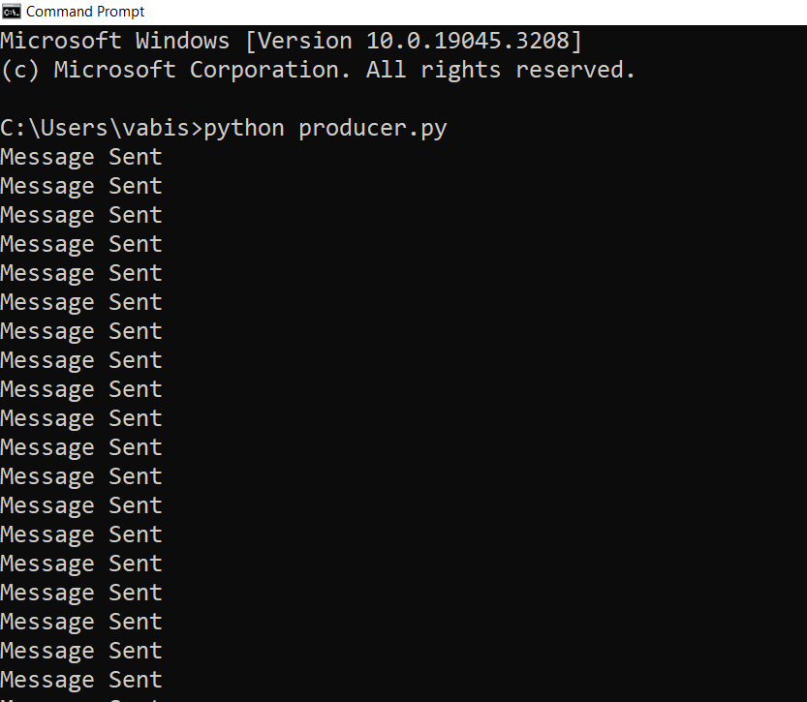

**Consumer.py-**

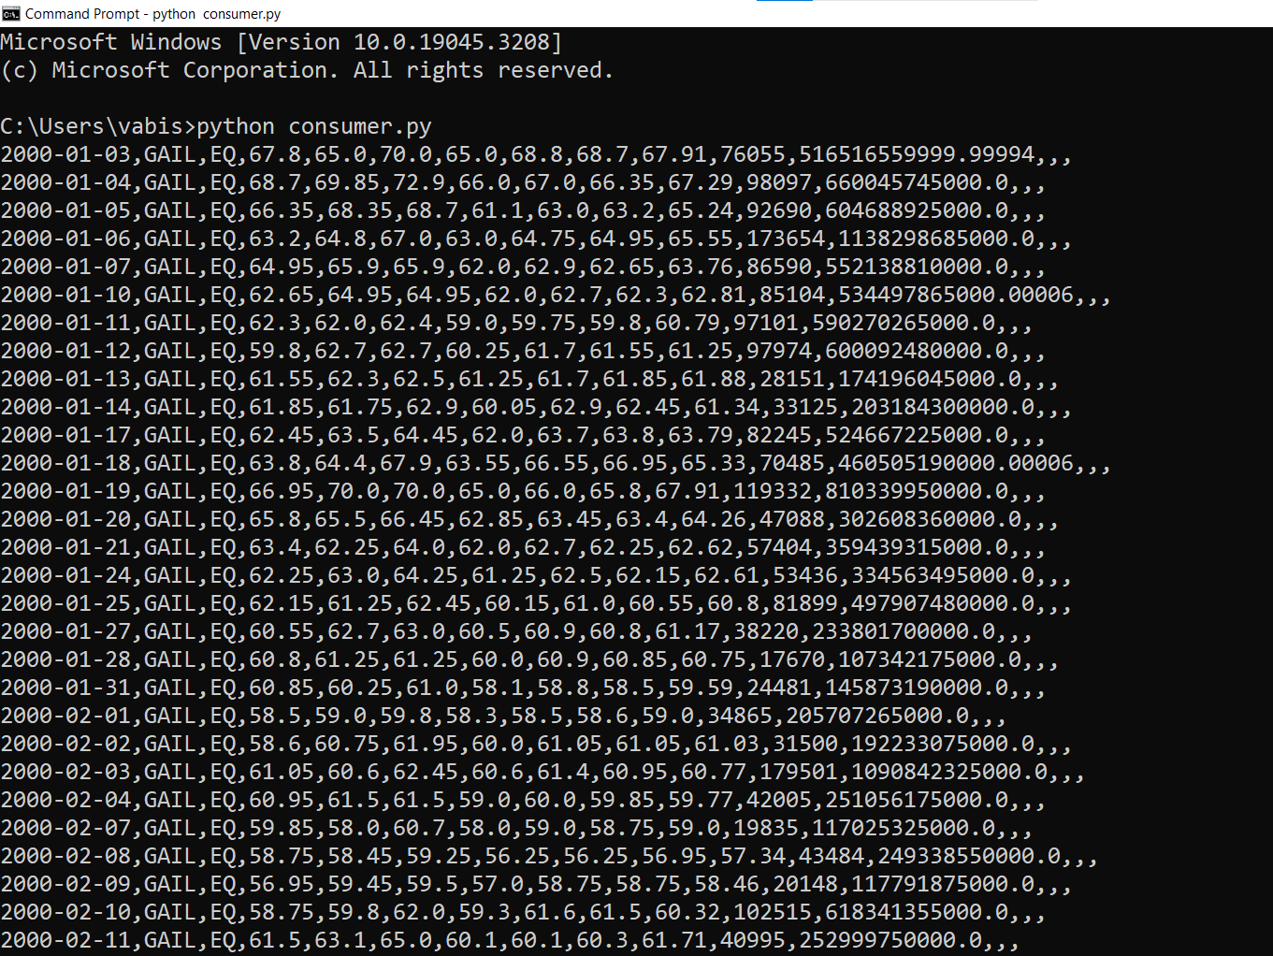

**Moving Average Graph:**



**Advantages of a 7-Day Moving Average:**

1. Short-Term Trend Identification: A 7-day moving average provides a more sensitive indicator of short-term price trends compared to longer-term moving averages. It can capture price fluctuations and identify shorter-term patterns in the data.
2. Immediate Response to Price Changes: A 7-day moving average reacts quickly to recent price changes, allowing traders and investors to respond promptly to market movements and adjust their strategies accordingly.
3. Enhanced Timing for Trading Decisions: By analyzing a 7-day moving average, traders can better time their entry or exit points in the market. It helps identify potential price reversals or short-term price trends for more timely and strategic trading decisions.

**Advantages of a 30-Day Moving Average:**

1. Smoothing Long-Term Price Trends: A 30-day moving average provides a smoother representation of long-term price trends. It filters out short-term noise and random fluctuations, providing a clearer view of the underlying direction of the market.
2. Identification of Long-Term Support and Resistance Levels: A 30-day moving average helps identify long-term support and resistance levels. It acts as a reference point to gauge the overall market sentiment and determine key levels where buying or selling pressure may be significant.
3. Reduced Impact of Daily Volatility: As a longer-term moving average, the 30-day average is less affected by daily price volatility. It helps investors focus on broader market trends and reduces the impact of short-term market noise, offering a more stable perspective on price movements.
4. Investment Strategy Assessment: A 30-day moving average helps evaluate the performance of investment strategies over a longer period. It provides insights into the sustainability of trends and helps identify potential shifts in market sentiment that may impact long-term investment decisions.

**Sources for images:**

Working of Streaming analytics: <https://dsstream.com/streaming-data-architecture/>

Financial Analysis: Photo by [Luke Chesser](https://unsplash.com/@lukechesser?utm_source=unsplash&utm_medium=referral&utm_content=creditCopyText) on [Unsplash](https://unsplash.com/s/photos/financial-analysis?utm_source=unsplash&utm_medium=referral&utm_content=creditCopyText)

Streaming Analytics: Photo by [Conny Schneider](https://unsplash.com/@choys_?utm_source=unsplash&utm_medium=referral&utm_content=creditCopyText) on [Unsplash](https://unsplash.com/photos/pREq0ns_p_E?utm_source=unsplash&utm_medium=referral&utm_content=creditCopyText)

Apache Kafka: <https://blog.knoldus.com/introduction-to-apache-kafka-terminology/>

Kafka Architecture: <https://data-flair.training/blogs/kafka-architecture/>

Evolution of Streaming : <https://www.datanami.com/2021/12/06/the-evolution-toward-data-maturity/>

Event Detection: <https://www.vectorstock.com/royalty-free-vector/two-color-detection-icon-from-artificial-vector-25693525>